**College of Saint Benedict & Saint John’s University**

**Computer Science Department**

**CMC.com**

**Phase 2**

**Team Name: !false**

**Team Leader: Trevor Wensman**

**Team Members: Alexis Neas, Jess Hansen, Jubie Alade, Zachary Vetter**

**Date: 3/20/18**

**[THIS PAGE IS INTENTIONALLY LEFT BLANK]**

**Table of Contents**

Detailed Task Decomposition……………………………………………………………………. 5

Class Diagram…………………………………………………………………………………….. 6

Use Case Mapping ………………………………………………………………………………. 7

Meeting Minutes…………………………………………………………………………………. 20

**Detailed Task Description**

* + Trevor: 20%
    - Created DBController, peer-reviewed other classes
  + Jess: 20%
    - Created AccountInteractions, Created User, Created Admin, Created AccountController, peer-reviewed other classes
  + Jubie: 20%
    - Created University, Created UniversityController, peer-reviewed other classes
  + Alexis: 20%
    - Created UserController, Created UserInteractions, Formatted TextDriver output, peer-reviewed other classes
  + Zachary: 20%
    - Created AdminInteractions, Created AdminController, Created Account, Created initial TextDriver, peer-reviewed other classes

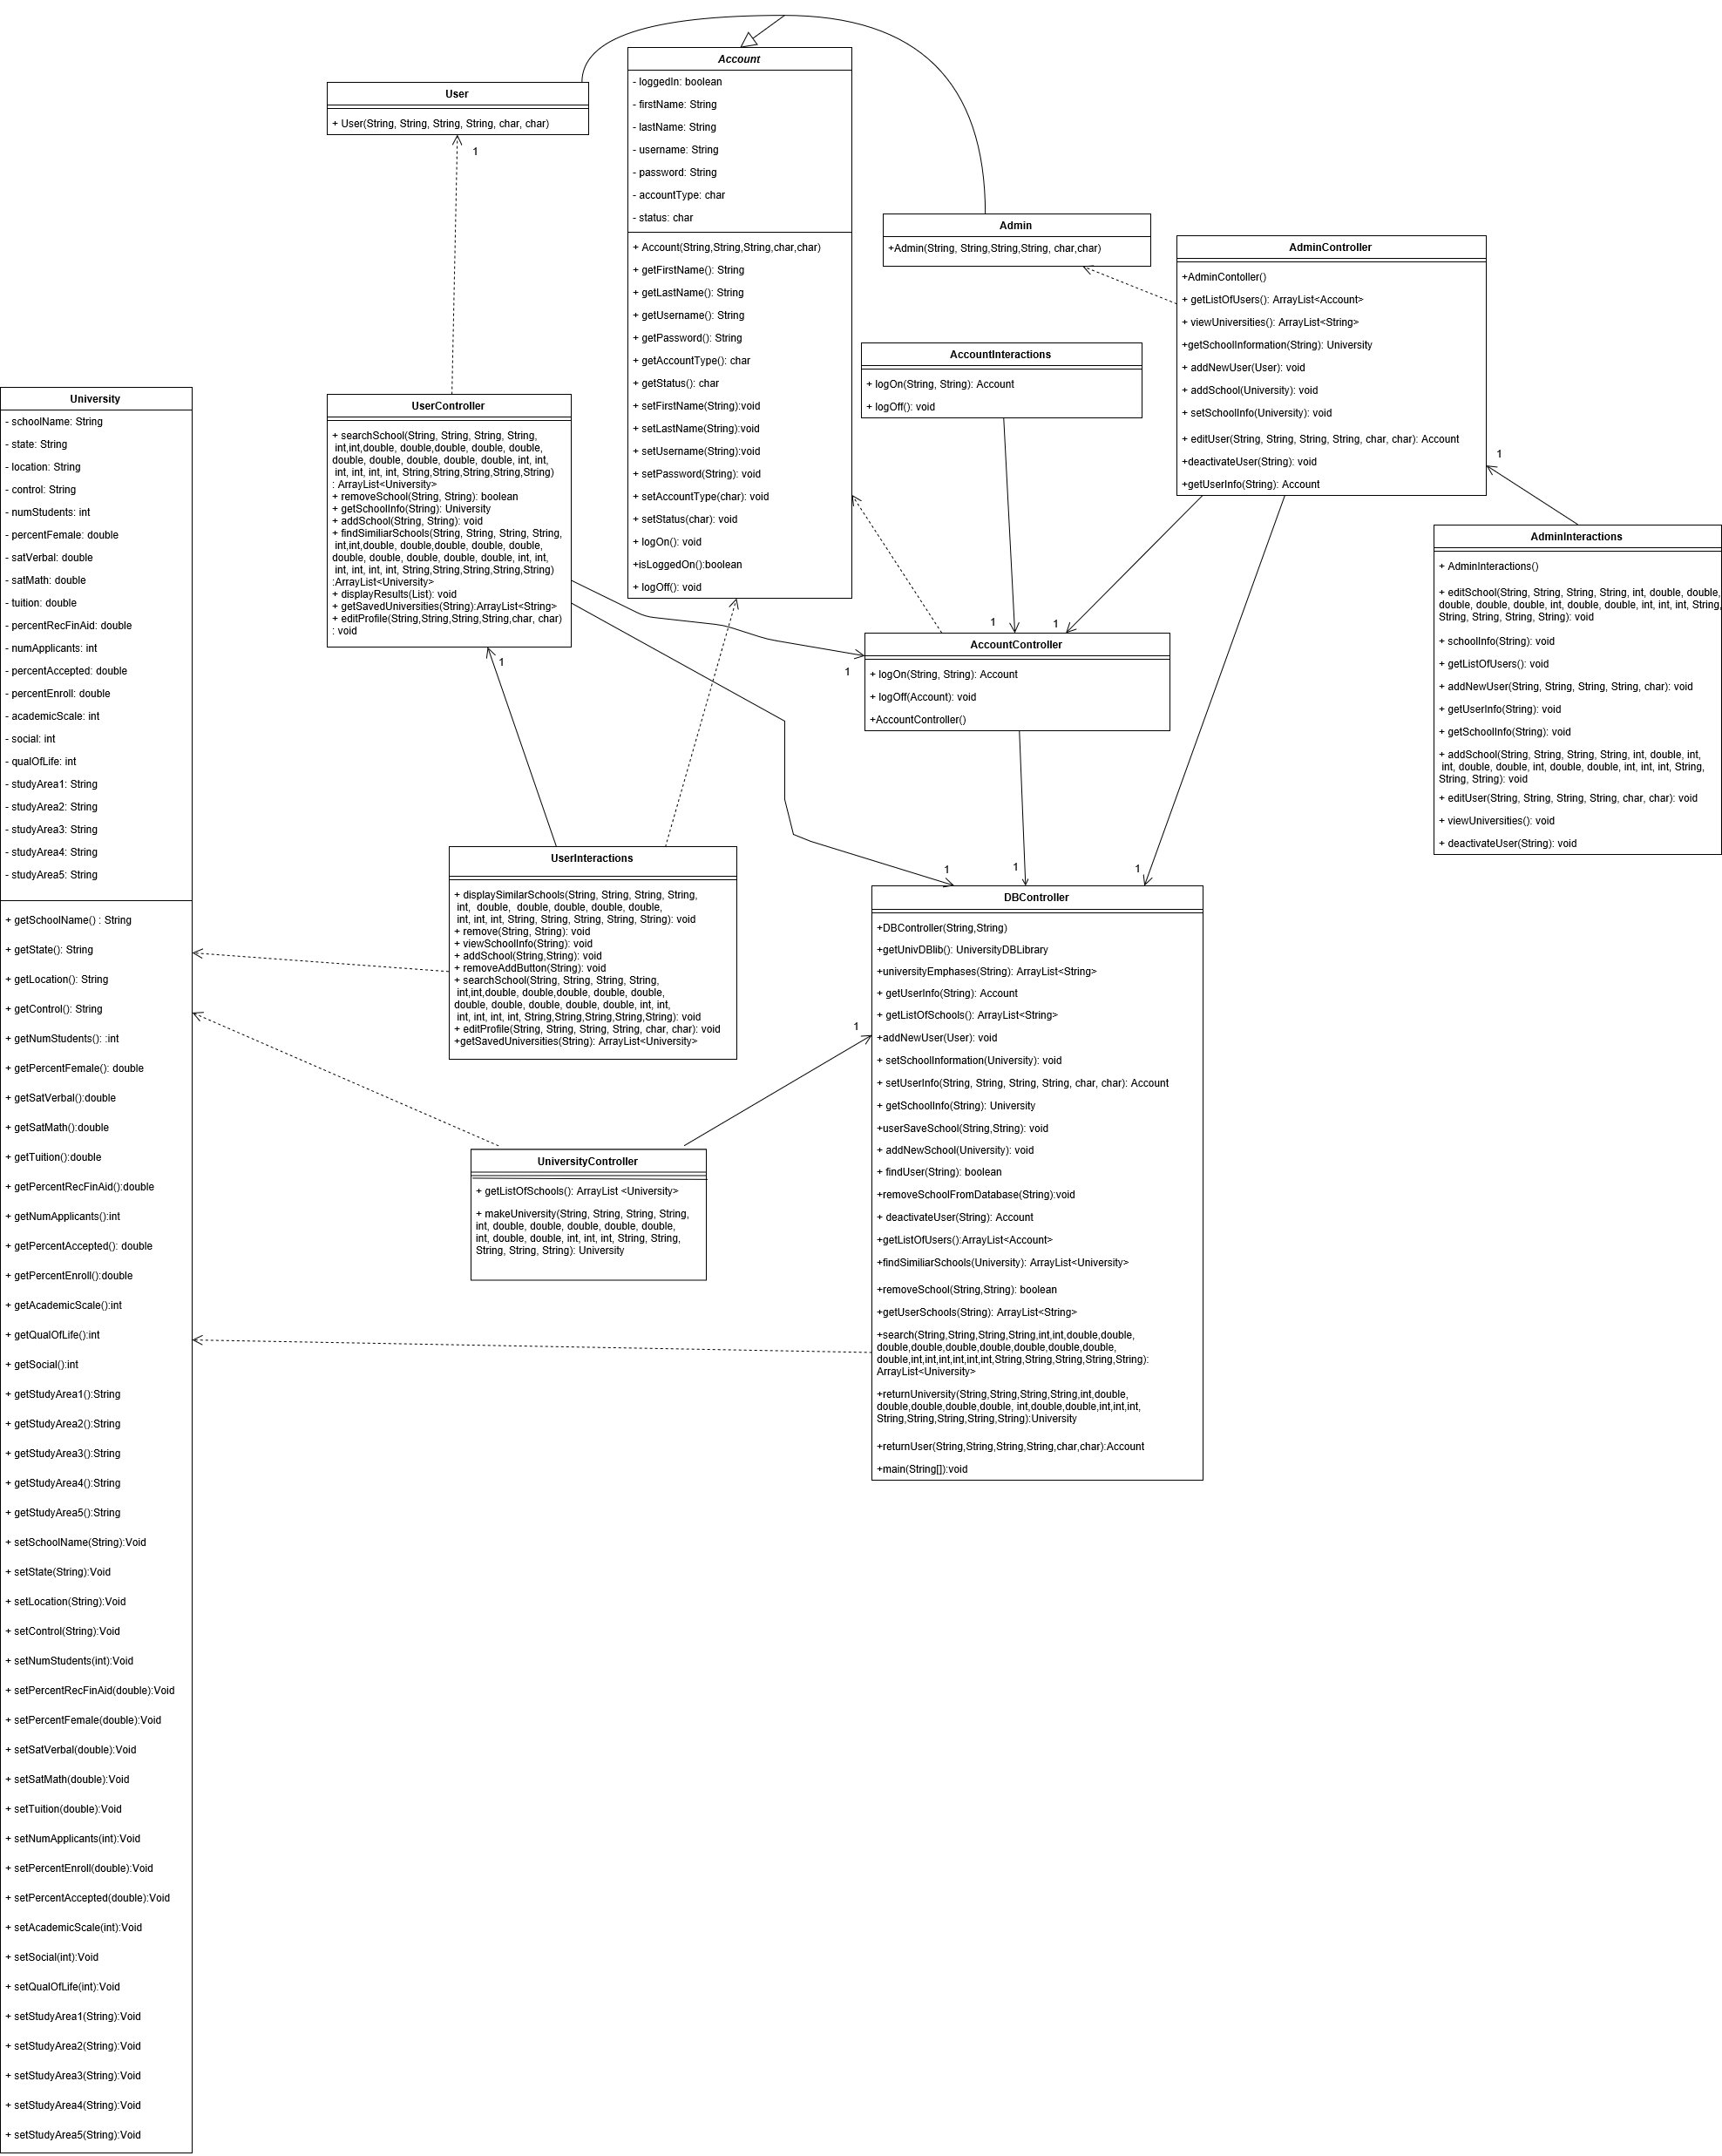

**U1: Log On, U2: View Admin Options, & U3: View User Options**

**Main Case:**

*Input:*

71 account = accountInteractions.logOn("juser", "user");

*Output:*

**\*\*\* Logging in with valid user credentials: \*\*\***

-- Username: juser Password: user --

The user account is now logged on

User Options: View Profile, View Saved Schools, Search Schools

User account log on status: true

*Input*:

123 account = accountInteractions.logOn("nadmin", "admin");

*Output*:

**\*\*\* Logging in with valid admin credentials: \*\*\***

Username: nadmin Password: admin

The admin account is now logged on

Admin Options: View Users, View Universities

**Test1: Log on with invalid username and password**

*Input:*

51 account = accountInteractions.logOn("ERROR", "ERROR");

*Output:*

**~~ TEST: Log on with invalid username and password ~~**

Logging in with invalid user credentials of U - ERROR, P - ERROR:

Invalid username or password

**Test2: Deactivated Account Log On**

*Input:*

54 adminInteractions.deactivateUser("juser");

55 account = accountInteractions.logOn("juser", "user");

*Output*:

**~~ TEST: Deactivated Account log in ~~**

Account has been deactivated: The account has not been logged on

**U4: Log Off**

*Input:*

111 System.out.println("\n\n *** Log Off ***");

112 accountInteractions.logOff(account);

113 System.out.println("User account log on status: "+account.isLoggedOn());

*Output:*

*** Log Off ***

The account is now logged off

User account log on status: false

*Input:*

171 accountInteractions.logOff(account);

*Output:*

**\*\*\* Log Off \*\*\***

The account is now logged off

Admin account log on status: false

**U5: View Universities**

*Input:*

150 System.out.println("\n\n*** Viewing list of schools currently in system ***");

151 adminInteractions.viewUniversities();

*Output*:

*** Viewing list of schools currently in system ***

ABILENE CHRISTIAN UNIVERSITY

ADELPHI

AMERICAN UNIVERSITY OF BEIRUT

ARIZONA STATE

AUBURN

AUGSBURG

BARD

BARNARD

BARUCH

BAYLOR UNIVERSITY

BENNINGTON

BOSTON COLLEGE

BOSTON UNIVERSITY

BRANDEIS

BROWN

BRYN MAWR

BUCKNELL

BUTLER

CAL TECH

CARNEGIE MELLON

CASE WESTERN

CCNY

CHALMERS UNIVERSITY OF TECHNOLOGY

CLARK UNIVERSITY

CLARKSON UNIVERSITY

COLGATE

COLLEGE OF NEWROCHELLE

COLORADO COLLEGE

COLORADO SCHOOL OF MINES

COLUMBIA

CONNECTICUT COLLEGE

COOPER UNION

CORNELL

CORPUS CHRISTI STATE U

DALLAS BAPTIST COLLEGE

DARTMOUTH

DEPAUL UNIVERSITY

DREW

EASTERN MICHIGAN

EASTMAN SCHOOL OF MUSIC

ECOLE NATIONALE SUPERIEURE DE TELECOMMUNICATION DE PARIS

ECOLE POLYTECHNIQUE

EMORY

FLORIDA ACADEMIC UNIVERSITY

FLORIDA STATE

FLORIDA TECH

FORDHAM

GEORGE WASHINGTON

GEORGETOWN

GEORGIA TECH

GLASSBORO STATE COLLEGE

GOLDEN GATE COLLEGE

GOTHENBURG UNIVERSITY

HAMPSHIRE COLLEGE

HARVARD

HOFSTRA

HOLY CROSS

HUNTINGTON COLLEGE

ILLINOIS TECH

JOHNS HOPKINS

JUILLIARD

LEHIGH UNIVERSITY

LESLEY

LEWIS AND CLARK

MANHATTANVILLE COLLEGE

MARIST COLLEGE

MASSACHUSETTS INSTITUTE OF TECHNOLOGY

MESA

MICHIGAN STATE

MONMOUTH COLLEGE

MORGAN STATE

MOUNT HOLYOKE

NEW JERSEY TECH

NEW YORK UNIVERSITY

NEWENGLAND COLLEGE

NEWJERSEY TECH

NEWYORK IT

NICHOLLS STATE

NORTH CAROLINA STATE UNIVERSITY

NORTHWESTERN

NOTRE DAME

OBERLIN

OHIO STATE

OKLAHOMA STATE UNIVERSITY

ORAL ROBERTS UNIVERSITY

OREGON INSTITUTE OF TECHNOLOGY

OREGON STATE

PENN STATE

POLYTECHNIC INSTITUTE OF NEWYORK

PRATT

PRINCETON

PURDUE

QUEENS

REED

RENSSELAER

RICE

ROCHESTER TECH

RUTGERS

SAINT ELIZABETHS

SAM HOUSTON STATE UNIVERSITY

SAN JOSE STATE

SETON HALL

SMITH

ST JOHNS UNIVERSITY

STANFORD

STEVENS

SUFFOLK COMMUNITY COLLEGE

SUNY ALBANY

SUNY BINGHAMTON

SUNY BUFFALO

SUNY PLATTSBURGH

SUNY PURCHASE

SUNY STONY BROOK

SWARTHMORE

SYRACUSE

Temp School

TEMPLE

TEXAS A&M

TEXAS CHRISTIAN UNIVERSITY

TOURO

TRINITY COLLEGE

TUFTS

TULANE

UNIVERSITE SAINT JOSEPH

UNIVERSITY OF ALABAMA

UNIVERSITY OF BRIDGEPORT

UNIVERSITY OF CALIFORNIA BERKELEY

UNIVERSITY OF CALIFORNIA DAVIS

UNIVERSITY OF CALIFORNIA LOS ANGELES

UNIVERSITY OF CALIFORNIA SAN DIEGO

UNIVERSITY OF CALIFORNIA SANTA CRUZ

UNIVERSITY OF CHICAGO

UNIVERSITY OF COLORADO

UNIVERSITY OF DENVER

UNIVERSITY OF EVANSVILLE

UNIVERSITY OF GEORGIA

UNIVERSITY OF HARTFORD

UNIVERSITY OF KANSAS

UNIVERSITY OF LOWELL

UNIVERSITY OF MAINE

UNIVERSITY OF MARYLAND

UNIVERSITY OF MASSACHUSETTS AMHERST

UNIVERSITY OF MICHIGAN

UNIVERSITY OF MINNESOTA

UNIVERSITY OF MISSISSIPPI

UNIVERSITY OF MISSOURI

UNIVERSITY OF MONTANA

UNIVERSITY OF NORTHCAROLINA

UNIVERSITY OF NOTRE DAME

UNIVERSITY OF OKLAHOMA

UNIVERSITY OF OREGON

UNIVERSITY OF PENNSYLVANIA

UNIVERSITY OF PITTSBURGH

UNIVERSITY OF PORTLAND

UNIVERSITY OF PUGET SOUND

UNIVERSITY OF ROCHESTER

UNIVERSITY OF SAN FRANCISCO

UNIVERSITY OF SOUTH DAKOTA

UNIVERSITY OF SOUTHERN CALIFORNIA

UNIVERSITY OF TEXAS

UNIVERSITY OF THE DISTRICT OF COLUMBIA

UNIVERSITY OF THE PACIFIC

UNIVERSITY OF THE SOUTH

UNIVERSITY OF TOLEDO

UNIVERSITY OF TULSA

UNIVERSITY OF VIRGINIA

UNIVERSITY OF WASHINGTON

UNIVERSITY WEST VIRGINIA

VANDERBILT

VASSAR

VILLANOVA

WALLA WALLA COLLEGE

WASHINGTON AND LEE

WAYNE STATE COLLEGE

WESLEYAN

WILLIAM PATERSON COLLEGE

WORCESTER

YALE

YANKTOWN COLLEGE

**U6: Add New School**

**\*\*\* Adding a new school called Temp School: \*\*\***

NOTE: The school must be changed each time you run Driver

*Input:*

154 adminInteractions.addSchool("Temp School", "Minnesota", "Urban", "State",

10, 50, 50, 50, 50000.00, 99,12, 100.0, 10, 3, 3, 3);

*Output:*

-- Added School..... Verifying School is there --

Name: Temp School

State: Minnesota

Location: Urban

Control: State

Number of Students: 10

% Female: 50.0

SAT Verbal: 50.0

SAT Math: 50.0

Tuition: 50000.0

% Receiving Financial Aid: 99.0

Number of Applications: 12

% Accepted: 100.0

% Enrolled: 10.0

Academic Scale: 3

Social Rating: 3

Quality of Life: 3

Study Area 1:

Study Area 2:

Study Area 3:

Study Area 4:

Study Area 5:

**U7: Edit School**

**\*\*\* Edit school: Temp School \*\*\***

*Input:*

161 adminInteractions.editSchool("Temp School", university.getState(),

university.getLocation(), university.getControl(),

university.getNumStudents(), 100, university.getSatVerbal(),

university.getSatMath(), university.getTuition(), university.getPercentRecFinAid(), university.getNumApplicants(),

… university.getPercentAccepted(), university.getPercentEnroll(),

university.getAcademicScale(), university.getSocial(),

university.getQualOfLife(), university.getStudyArea1(), university.getStudyArea2(), university.getStudyArea3(),

166 university.getStudyArea4(), university.getStudyArea5());

*Output: No output for edit school.*

**U8: View Users**

**\*\*\* Get List of Accounts \*\*\***

*Input:*

126 adminInteractions.getListOfUsers();

*Output:*

Juser

Luser

Nadmin

Trevor

**-- Get updated user information --**

*Input:*

148 adminInteractions.getUserInfo("trevor");

*Output:*

First: ROVERT

Last: Wensman

Username: trevor

Password: password

Type: u

Status: N

**-- Get updated user information --**

*Input:*

140 adminInteractions.getUserInfo("trevor");

*Output:*

First: Trevor

Last: Wensman

Username: trevor

Password: password

Type: u

Status: N

**U9: Add Users**

**\*\*\* Add New Account \*\*\***

*Input:*

128 adminInteractions.addNewUser("Trevor", "Wensman","trevor",

"password", 'u');

*Output:*

Display updated list of users

*Input:*

130 adminInteractions.getListOfUsers();

*Output:*

Juser

Luser

Nadmin

trevor

**U10: Edit Users and U11: Save Account Information**

**\*\*\* Edit Account Information \*\*\***

*Input:*

146 adminInteractions.editUser("ROVERT", "Wensman", "trevor", "password",'u', 'N');

*Output:* No output for edit users.

**U12: Save School**

**-- Updated List of Saved Universities: --**

*Input:*

106 userInteractions.getSavedUniversities(account.getUsername());

*Output:*

University of Minnesota

**Adding University of Minnesota to current user account**

*Input:*

104 userInteractions.addSchool("University of Minnesota",

account.getUsername());

*Output:*

School has been added.

**U13: Search Schools & U15: View Results**

**\*\*\* Search schools and View Search Results: Schools in California \*\*\***

*Input:*

83 userInteractions.searchSchool("!", "CALIFORNIA","!" ,"!",//SchoolName,

State,

0, 10000,//NumStudents

-2,-2,//%Female

-2,-2,//SATVerbal

-2,-2,//SATMath

... -2,-2,//Expenses

-2,-2,//PercentEnrolled

-2,-2,//AcademicsScale

-2,-2,//Social

-2,-2,//Academics

93 "", "","", "","");

*Output:*

CAL TECH

GOLDEN GATE COLLEGE

SAN JOSE STATE

STANFORD

UNIVERSITY OF CALIFORNIA BERKELEY

UNIVERSITY OF CALIFORNIA DAVIS

UNIVERSITY OF CALIFORNIA LOS ANGELES

UNIVERSITY OF CALIFORNIA SAN DIEGO

UNIVERSITY OF CALIFORNIA SANTA CRUZ

UNIVERSITY OF SAN FRANCISCO

UNIVERSITY OF SOUTHERN CALIFORNIA

UNIVERSITY OF THE PACIFIC

**U14: Deactivate**

**\*\*\* Deactivate user \*\*\***

*Input:*

138 adminInteractions.deactivateUser("trevor");

*Output:*

Original Account information

First: Trevor

Last: Wensman

Username: trevor

Password: password

Type: u

Status: Y

**U16: View Saved Schools**

**-- Display Saved Universities: --**

*Input:*

110 userInteractions.getSavedUniversities(account.getUsername());

*Output:*

No saved universities

**U17: View Profile**

**\*\*\* View Profile \*\*\***

*Input:*

75 userInteractions.viewProfile(account.getUsername());

*Output:*

First name: Juser

Last name: User

Username: juser

Password: user

Account type: u

**-- Check to ensure the account name is changed --**

*Input:*

80 userInteractions.viewProfile(account.getUsername());

*Output:*

First name: Alexis

Last name: Neas

Username: juser

Password: user

Account type: u

**U18: Edit Profile**

**\*\*\* Edit Profile: Change name to Alexis Neas \*\*\***

Changes have been saved

*Input:*

78 userInteractions.editProfile("Alexis", "Neas", account.getUsername(),

account.getPassword(), account.getAccountType(), account.getStatus());

*Output: N/A*

**U19: Remove Schools**

**\*\*\* Removing school from User's List of Schools: \*\*\***

*Input:*

108 userInteractions.remove("University of

Minnesota",account.getUsername());

*Output:*

School has been removed

**U20: View School Information**

**\*\*\* View School Information: University of Minnesota \*\*\***

*Input:*

96 userInteractions.viewSchoolInfo("UNIVERSITY OF MINNESOTA");

*Output:*

Name: UNIVERSITY OF MINNESOTA

State: MINNESOTA

Location: URBAN

Control: STATE

Number of Students: 40000

% Female: 45.0

SAT Verbal: 490.0

SAT Math: 557.0

Tuition: 13772.0

% Receiving Financial Aid: 50.0

Number of Applications: 8500

% Accepted: 80.0

% Enrolled: 60.0

Academic Scale: 4

Social Rating: 3

Quality of Life: 4

Study Area 1: AGRICULTURE

Study Area 2: ENGINEERING

Study Area 3:

Study Area 4:

Study Area 5:

**U21: Add School To Profile**

**\*\*\* Add school to User's saved universities: \*\*\***

*Input:*

102 userInteractions.getSavedUniversities(account.getUsername());

*Output:*

Original List of Saved Schools

No saved universities

**U22: Display Similar Recommendations**

**\*\*\* Display Top 5 Schools Similar to University of Minnesota \*\*\***

*Input:*

98 userInteractions.displaySimilarSchools("UNIVERSITY OF MINNESOTA");

*Output:*

UNIVERSITY OF CALIFORNIA LOS ANGELES

UNIVERSITY OF WASHINGTON

TEMPLE

OHIO STATE

SUNY BUFFALO

**\*\*\* Get information for specific account \*\*\***

*Input:*

133 adminInteractions.getUserInfo("trevor");

*Output:*

First: Trevor

Last: Wensman

Username: trevor

Password: password

Type: u

Status: Y

**Meeting Minutes:**

**Meeting 5**: Phase 2

Time: 2:20- 3:40 (1.3 hours)

Team Leader: Trevor Wensman

* Figured out how to access the database library
* Assigned Classes to people
* Communication Diagrams

-Do we need to actually pass user in parameter of remove school?

-Why is there an addNewUser method for user?

-saveSchool vs. addSchoolToUserList ( should require either string or university) same w/ addSchool????

-findSimilarSchool should return a list of schools, not a string

**Meeting 6**: Phase 2

Time 8:00 - 9:00 (1 hour)

Team Leader Trevor Wensman

* Went over group questions.
* Assigned work to be done for next meeting.

Questions:

Do we actually have to have a University class? We need to access the database every time so why do we need to store it?

**Meeting 6**: Phase 2

Time 6:30 - 9:15 (2.75 hours)

Team Leader Trevor Wensman

* Put together code
* Made sure it compiled
* Make sure your own classes are reflected correctly in the Class Diagram

Questions

Are User’s saved schools also stored in the User object or can we just get them from the database when we need them?

Search efficiency-- do we need to pass all parameters, or is there a better way to do it?

Where does the current user get stored? Not in database, but where?

Just for clarification-- can users edit while looking at info, or does it require an action from user?

**Meeting 7**: Phase 2 3-13-18

Time: 7:30-9:30 (2 hours)

* Update all javadoc
* Peer review the classes
  + Update class diagram
* Begin driver controller
* Take note for what you use for each use case

Questions:

Hardcoding into driver class or ask for user input?

How to show incorrect password or username if hardcoding?

**Meeting 8**: Phase 2 3-15-18

Time: 5:30-7:30 (2 hours)

* Updating all javadocs
* Revising programs and classes
* Updates to class diagram
* GitHub and Eclipse implementation

**Meeting 9**: Phase 2 3-16--18

Time: 6:00-9:00 (3 hours)

* Begin testing and driver
* Complete interaction classes
  + Revisions to database interaction

**Meeting 10**: Phase 2 3-18-18

Time: 7:00-10:30 (3.5 hours)

* Class diagram work
* Continue driver
* Finish Interactions and Controller classes
  + Search and Find Similar Schools: work

**Meeting 11**: Phase 2 3-19-18

Time: 5:30 - 10:30 (5 hours)

* Revisions to Search method and Find Similar Schools method
* Finalize Driver
* Format outputs
* Review and Revise Class Diagram

README file-- what to include?

Include TextDriver in class diagram?

Formatting of the mapping-- what does it mean?

**Meeting 12**: Phase 2 3-20-18

Time: 7:00- 10:30 (3.5 hours)

* Finalize driver and other classes
* Create and put everything into Phase 2 folder
* Finish report (use report 1 as an outline/example)

Total Meeting Minutes: 24.05 hours